

Jawaharlal Nehru Engineering College

**Journal**

By

**512127**

**Shaikh Altamash**

Web Technology Lab

(MCA )

For

FY MCA Part-1

2020-21

**SUBJECT INDEX**

|  |  |
| --- | --- |
| 1 | Assignment on HTML |
| 2 | Assignment on CSS |
| 3 | Assignment on Bootstrap |
| 4 | Assignment on Java script |
| 5 | Assignment on Jquery |
| 6 | Assignment on PHP basic |
| 7 | Assignment on database operation in PHP |
| 8 | Assignment on AJAX with PHP |
| 9 | Assignment on PHP Unit Testing |
| 10 | Assignment on CMS:wordpress |
| 11 | Assignment on FTP client &Cpanel web hosting |
| 12 | Responsive Web Site development (Mini Project) |

**1. Assignment on HTML**

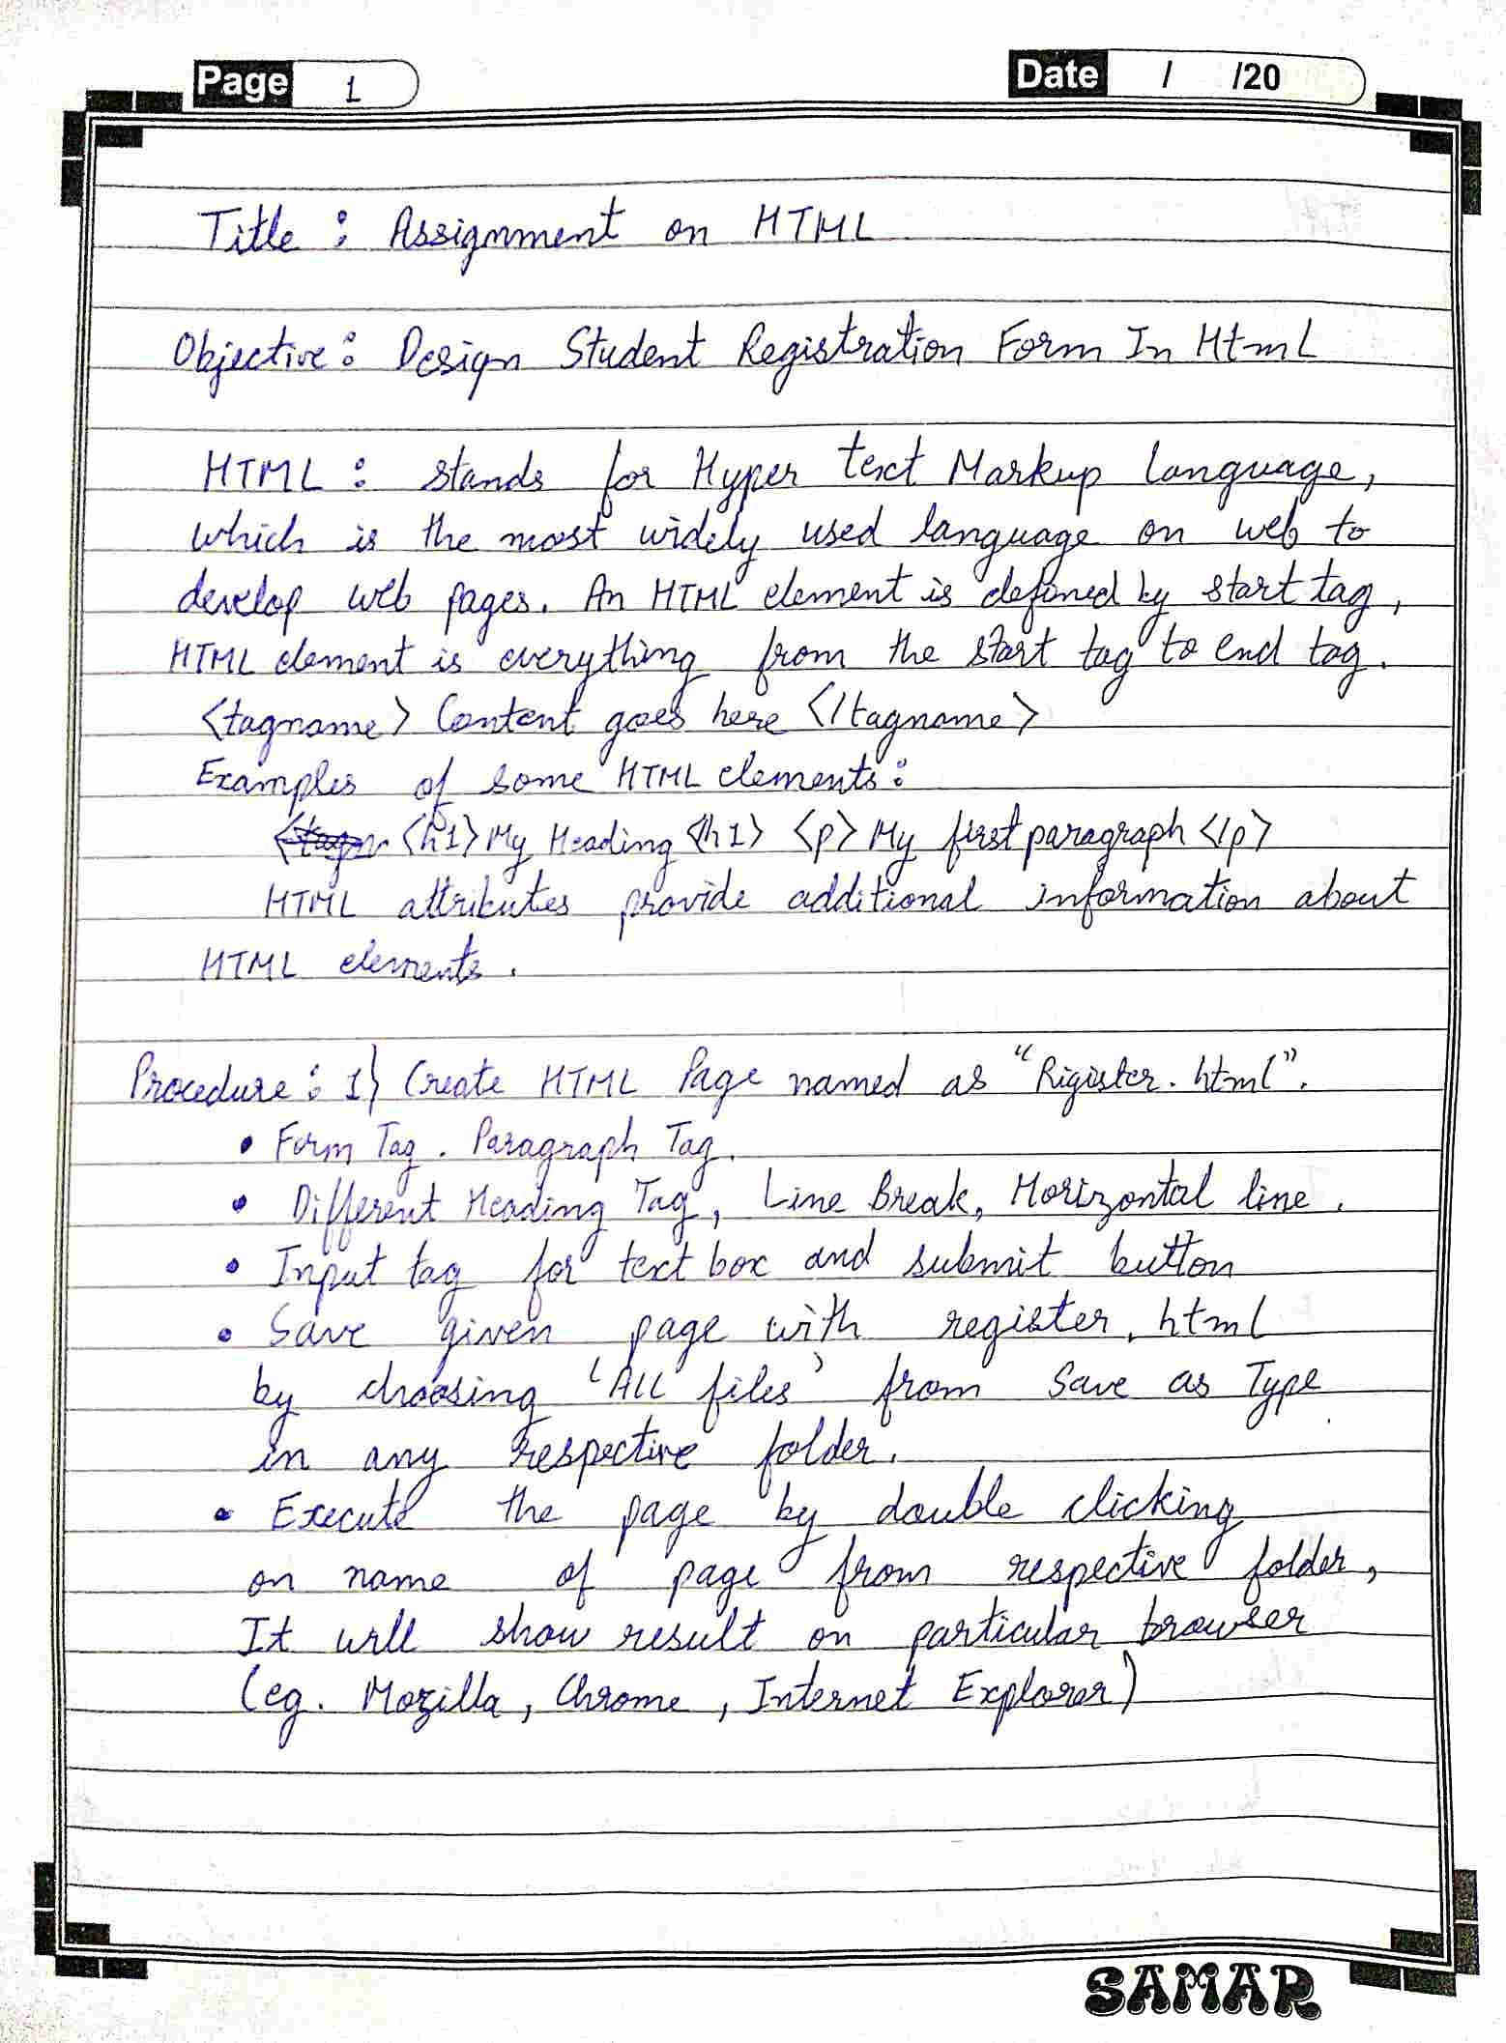

**Source Code :**

<html>

<head>

<title>Restricted Form</title>

<style>

form{background-image:url("https://cdn.wallpapersafari.com/87/18/aQcVXo.gif");

color:pink;

border:10px double;

margin:20px;

padding:10px;

text-align:center;

}

input{ margin:7px;

padding:7px;}

.l{margin-left:90px;}

.m{margin-left:95px;}

.n{margin-left:119px;}

.k{margin-left:130px;}

.o{margin-left:115px;}

input[type=submit]:hover {background-color:grey;

}

input[type=reset]:hover {background-color:grey;}

select{

width: 20%;

padding: 7px 10px;

border: none;

border-radius: 4px;

background-color: #f1f1f1;

}

</style>

</head>

<body>

<h1 align=center>Registration Form</h1>

<div>

<form action="http://i.stack.imgur.com/tc3b6.jpg">

<b><label for="Fname" size="20" >First Name:</lable>

<input type="text" id="Fname" name="Fname" placeholder="Enter First Name" class="l"><br>

<label for="Lname" size="20">Last Name:</lable>

<input type="text" id="Lname" name="Lname" placeholder="Enter Last Name" class="m"><br>

<label for="address" size="20">Address:</label>

<input type="address" id="address" name="address" placeholder="Enter Address" class="n"><br>

<label for="mobile" size="20">Mobile:</lable>

<input type="mobile" id="mobile" name="mobile" placeholder="Enter Mobile Number" class="k"><br>

<label for="gender" size="20">Gender:</lable>

<input type="radio" id="male" name="gender" value="male">Male

<input type="radio" id="female" name="gender" value="female">Female<br>

<label for="color" size="20">Color:</lable>

<input type="checkbox" id="red" name="color" value="red">Red

<input type="checkbox" id="blue" name="color" value="blue">Blue

<input type="checkbox" id="green" name="color" value="green">green<br>

<fieldset>

<legend>Education Info</legend>

<label for="course">Course:</label>

<input type="text" list="course" class="o">

<datalist id=course >

<option> MCA

<option> MBA

<option> MA

</datalist>

</fieldset><br>

<label for="country">Country:</label>

<select id="country" name="country" class="m">

<option value="australia">India</option>

<option value="canada">South Korea</option>

<option value="usa">Japan</option>

<option value="usa">France</option>

</select><br>

<input type="submit" value="submit">

<input type="reset" value="cancel" >

<b></form>

</div>

</body>

</html>

**Output:**

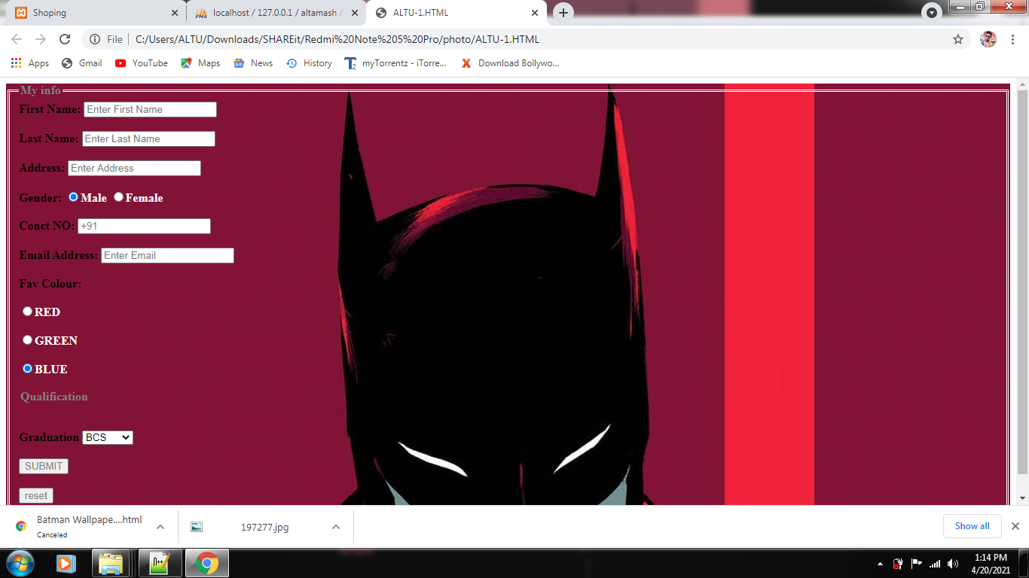

**2. Assignment on CSS**

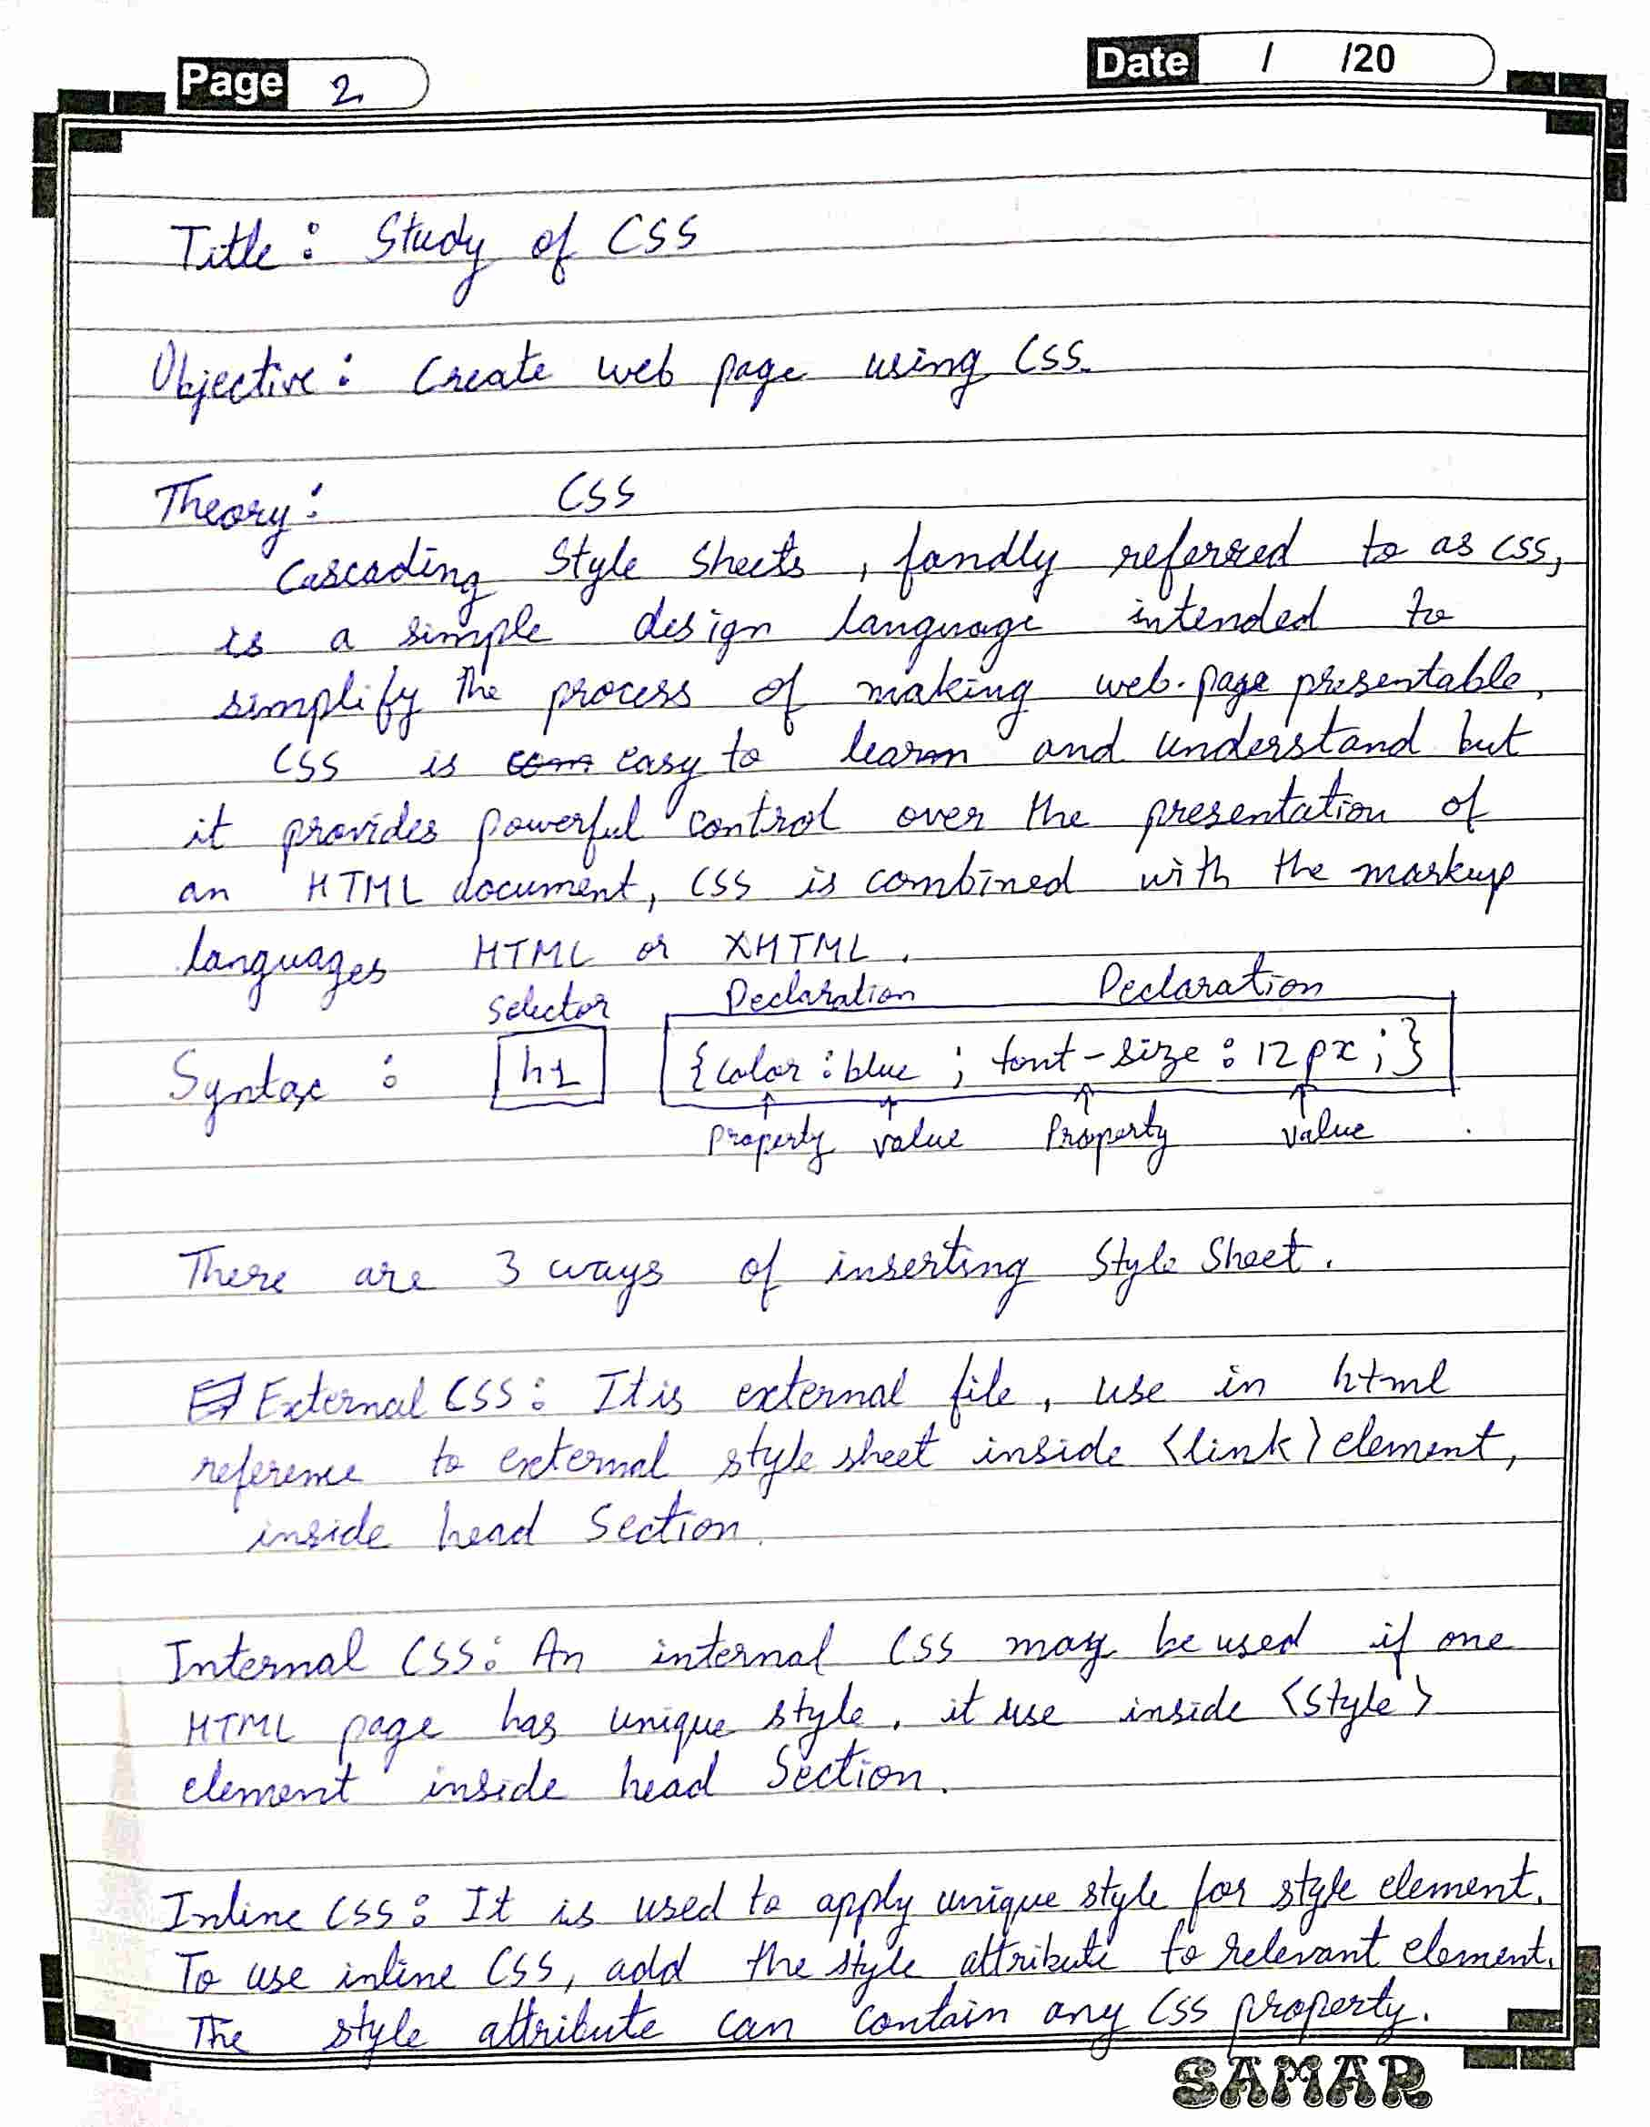

## Source Code:

<html>

<head>

<title>Page Title</title>

<style>

div{

border:2px outset brown;

background-color:Lightgreen;

width:150px;

height:200px;

margin:15px;

padding:10px;

float:left;

box-shadow:8px 15px 10px DarkGreen;

overflow:auto;

}

div:hover{ border:10px outset DarkGoldenRod;

box-shadow:8px 15px 10px DarkSalmon;

}

img{

display:block;

margin-left:auto;

margin-right:auto;

width:50%;

border:2px outset brown;

}

img:hover{ border:5px outset brown;

}

.bcolor{background-color:Gold;}

</style>

</head>

<body>

<h1>Heading</h1>

<p>Paragrah</p>

<div>

<img src="https://implyingrigged.info/w/images/thumb/0/07/Jojo_logo.png/250px-Jojo_logo.png" height="50" width="50">

<p>JoJo's Bizarre Adventure, often shortened to JoJo or JJBA, is a shōnen and seinen manga. It follows the journeys of the Joestar family members across generations. </p>

</div>

<div class="bcolor">

<p>JoJo's Bizarre Adventure, often shortened to JoJo or JJBA, is a shōnen and seinen manga. It follows the journeys of the Joestar family members across generations. </p>

</div>

<div>

<p>JoJo's Bizarre Adventure, often shortened to JoJo or JJBA, is a shōnen and seinen manga. It follows the journeys of the Joestar family members across generations. </p>

</div>

<div class="bcolor">

<p>JoJo's Bizarre Adventure, often shortened to JoJo or JJBA, is a shōnen and seinen manga. It follows the journeys of the Joestar family members across generations. </p>

</div>

</body>

</html>

**Output:**

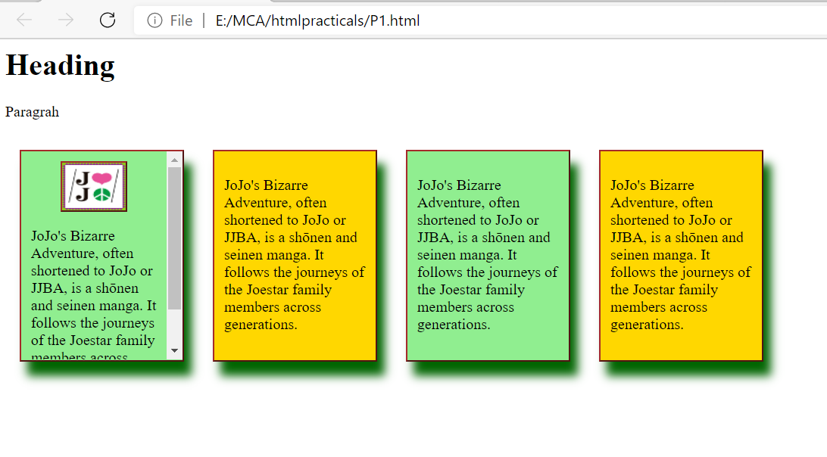

**3. Assignment on Bootstrap**

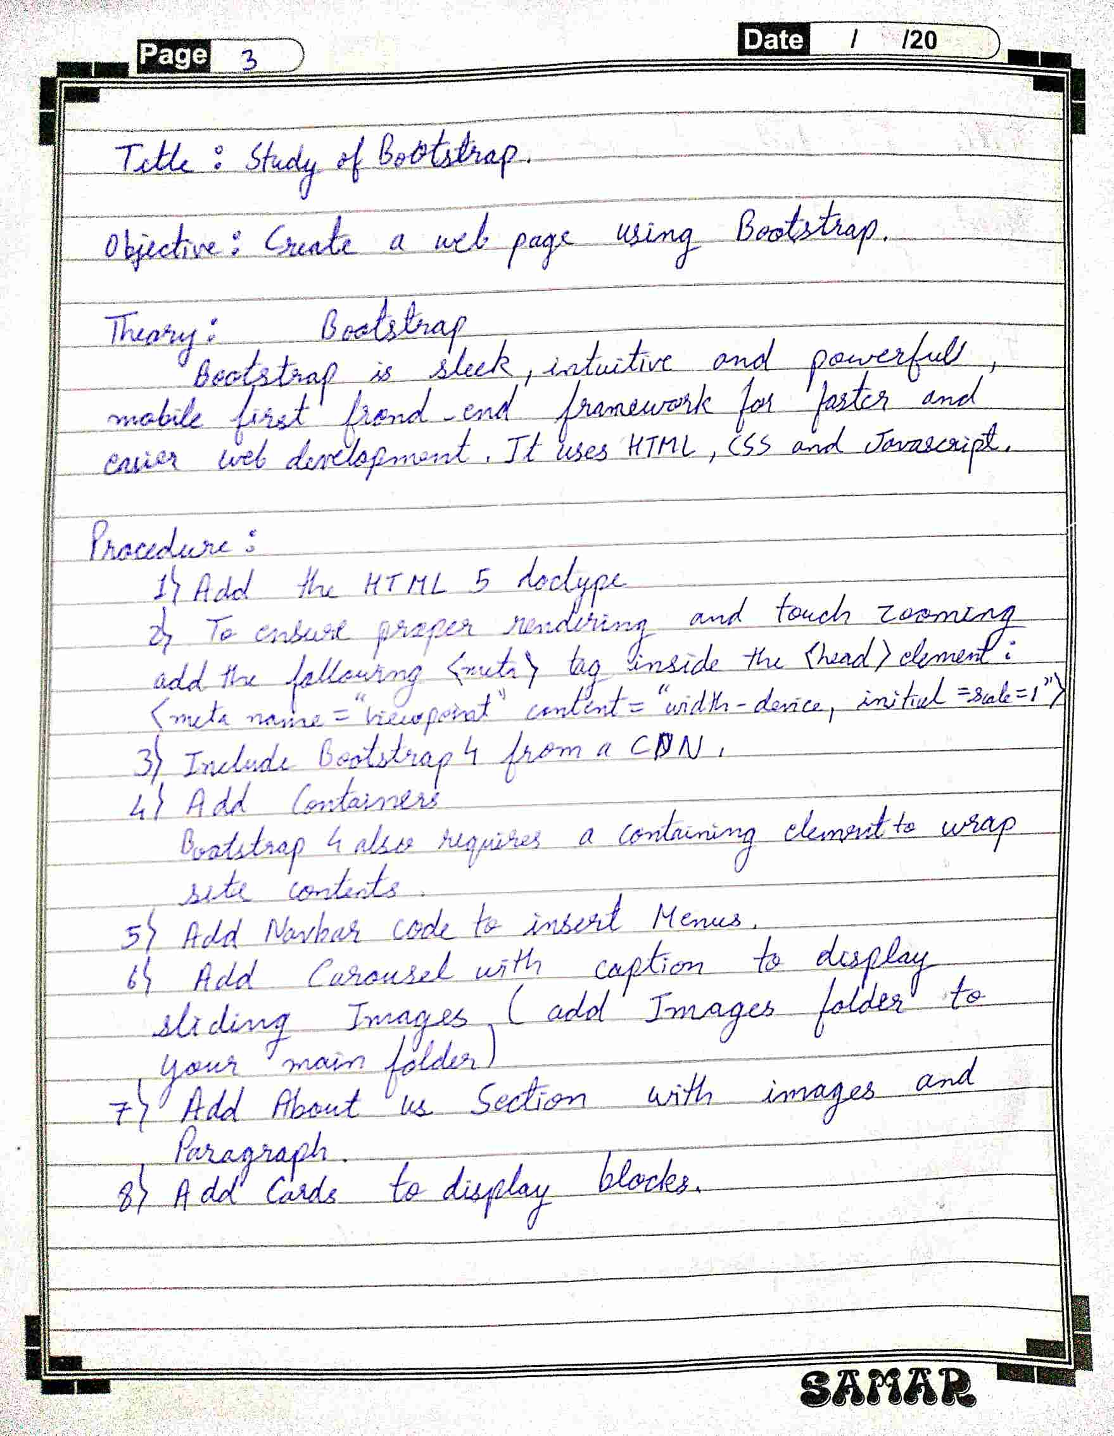

**Source Code:**

<!DOCTYPE html>

<html lang="en">

<head>

<title>Bootstrap 4 Example</title>

<meta charset="utf-8">

<meta name="viewport" content="width=device-width, initial-scale=1">

<link rel="stylesheet" href="https://maxcdn.bootstrapcdn.com/bootstrap/4.5.2/css/bootstrap.min.css">

<script src="https://ajax.googleapis.com/ajax/libs/jquery/3.5.1/jquery.min.js"></script>

<script src="https://cdnjs.cloudflare.com/ajax/libs/popper.js/1.16.0/umd/popper.min.js"></script>

<script src="https://maxcdn.bootstrapcdn.com/bootstrap/4.5.2/js/bootstrap.min.js"></script>

<link rel="preconnect" href="https://fonts.gstatic.com">

<link href="https://fonts.googleapis.com/css2?family=Merriweather:ital,wght@1,700&display=swap" rel="stylesheet">

<style>

*{font-family: 'Merriweather', serif;}

/* Make the image fully responsive */

.carousel-inner img {

width: 100%;

height: 100%;

}

</style>

</head>

<body>

<header>

<div class="container-fluid">

<h1 class="text-center">Welcome to Wild Life</h1>

<p></p>

</div>

<nav class="navbar navbar-expand-lg navbar-dark bg-dark">

<div class="container-fluid">

<a class="navbar-brand" href="#">Brand</a>

<button class="navbar-toggler" type="button" data-bs-toggle="collapse" data-bs-target="#navbarSupportedContent" aria-controls="navbarSupportedContent" aria-expanded="false" aria-label="Toggle navigation">

<span class="navbar-toggler-icon"></span>

</button>

<div class="collapse navbar-collapse" id="navbarSupportedContent">

<ul class="navbar-nav me-auto">

<li class="nav-item">

<a class="nav-link active" aria-current="page" href="#">Home</a>

</li>

<li class="nav-item">

<a class="nav-link" href="#">About</a>

</li>

<li class="nav-item dropdown">

<a class="nav-link dropdown-toggle" href="#" id="navbarDropdown" role="button" data-bs-toggle="dropdown" aria-expanded="false">

Addmission

</a>

<ul class="dropdown-menu" aria-labelledby="navbarDropdown">

<li><a class="dropdown-item" href="#">Action</a></li>

<li><a class="dropdown-item" href="#">Another action</a></li>

<li><hr class="dropdown-divider"></li>

<li><a class="dropdown-item" href="#">Something else here</a></li>

</ul>

</li>

<li class="nav-item">

<a class="nav-link disabled" href="#" tabindex="-1" aria-disabled="true">Disabled</a>

</li>

</ul>

<form class="d-flex">

<input class="form-control me-2" type="search" placeholder="Search" aria-label="Search">

<button class="btn btn-outline-success" type="submit">Search</button>

</form>

</div>

</div>

</nav>

<div id="demo" class="carousel slide" data-ride="carousel">

<ul class="carousel-indicators">

<li data-target="#demo" data-slide-to="0" class="active"></li>

<li data-target="#demo" data-slide-to="1"></li>

<li data-target="#demo" data-slide-to="2"></li>

</ul>

<div class="carousel-inner">

<div class="carousel-item active">

<img src="image/YdsT2qy.jpg" alt="Los Angeles" width="1100" height="500">

<div class="carousel-caption">

<h3>Los Angeles</h3>

<p>We had such a great time in LA!</p>

</div>

</div>

<div class="carousel-item">

<img src="image/wolf.jpg" alt="Chicago" width="1100" height="500">

<div class="carousel-caption">

<h3>Chicago</h3>

<p>Thank you, Chicago!</p>

</div>

</div>

<div class="carousel-item">

<img src="image/jchyGxm.jpg" alt="New York" width="1100" height="500">

<div class="carousel-caption">

<h3>New York</h3>

<p>We love the Big Apple!</p>

</div>

</div>

</div>

<a class="carousel-control-prev" href="#demo" data-slide="prev">

<span class="carousel-control-prev-icon"></span>

</a>

<a class="carousel-control-next" href="#demo" data-slide="next">

<span class="carousel-control-next-icon"></span>

</a>

</div>

</header>

<section>

<div class="container-fluid">

<h1 class="text-center">

About us</h1>

<hr class="w-25 mx-auto">

<div class="row">

<div class="col-lg-6 col-md-6 col-12">

<img src="image/cheetah.jpg" class="img-fluid">

</div>

<div class="col-lg-6 col-md-6 col-12">

<h3> Program Outline</h3>

<p> Wildlife crime is a billion-dollar threat that spans across countries and continents. Between poaching, illegal trade and regulation issues, there are many immediate concerns facing some of the world’s most endangered species. Educated, knowledgeable professionals working in the field and in the lab are critical resources in the protection and conservation of the U.S. and international wildlife populations. The University of Florida’s online graduate program in Wildlife Forensic Sciences and Conservation, offered through the Wildlife Ecology and Conservation department and the Maples Center for Forensic Medicine, aims to help bridge the knowledge gap in wildlife forensic science. Being an adequately trained professional working in wildlife conservation, ecology, and animal protection will help combat the growing problems in wildlife crime. Through this program, students will learn how critical the conservation of the world’s wildlife is to our ecosystem and natural environment.

contact </p>

<button class="btn btn-primary">Know more</button>

</div>

</div>

</div>

</section>

</body>

</html>

**Output:**

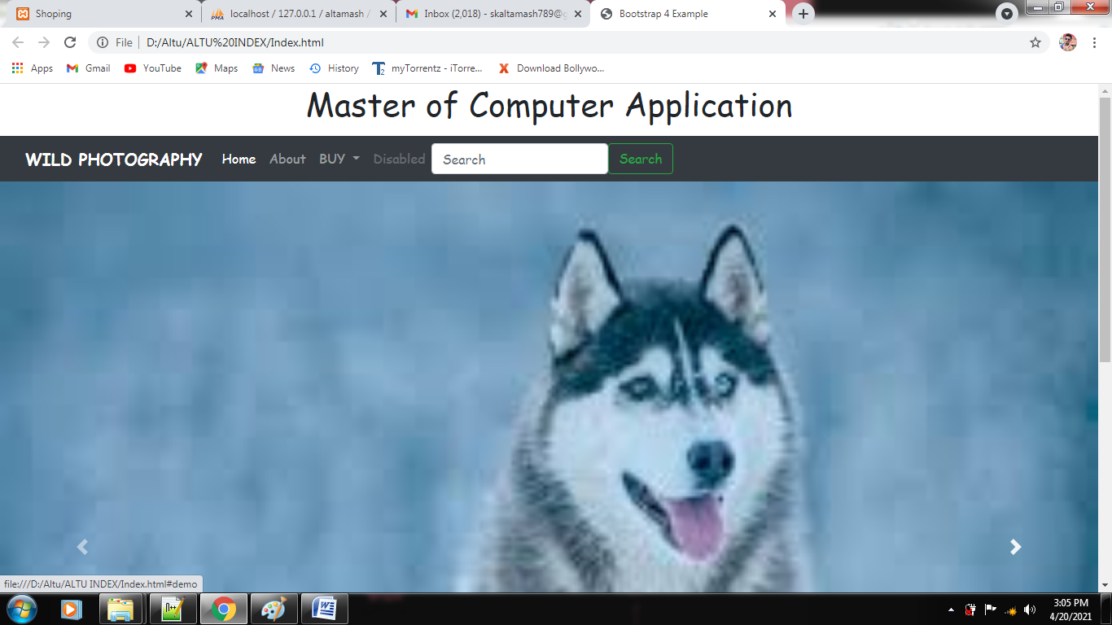

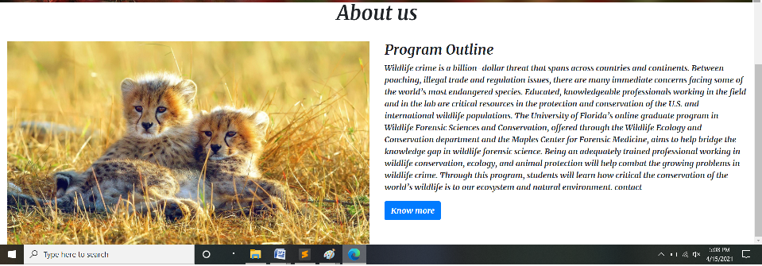

**4. Assignment on JavaScriipt**

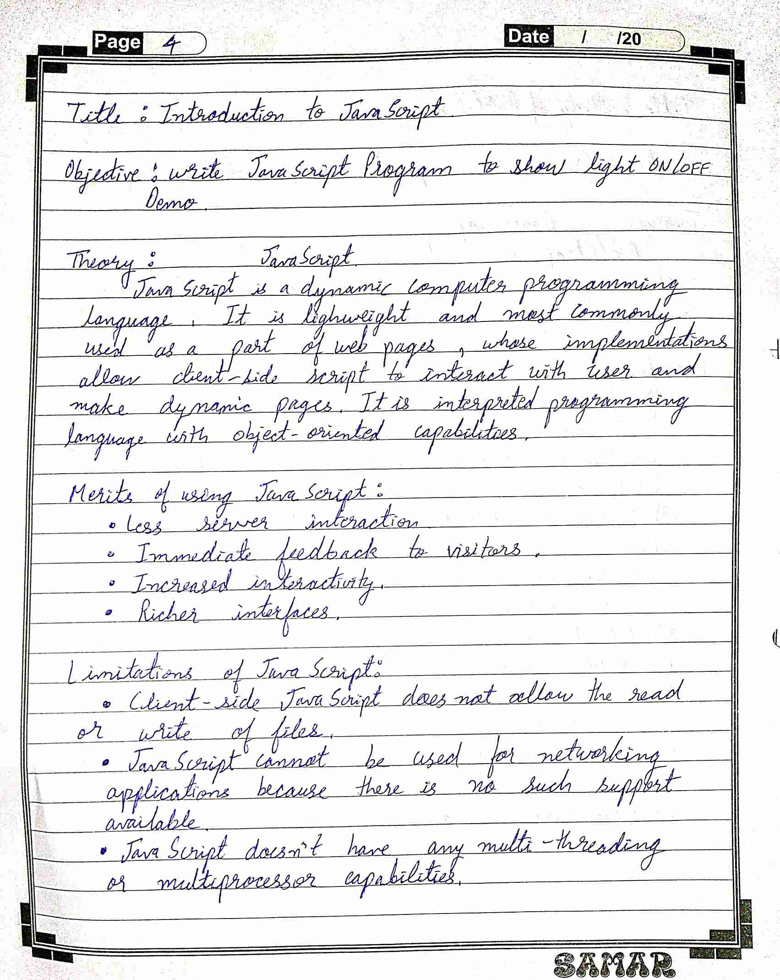

**Source Code:**

<!DOCTYPE html>

<html>

<body>

<h2>What Can JavaScript Do?</h2>

<p>JavaScript can change HTML attribute values.</p>

<p>In this case JavaScript changes the value of the src (source) attribute of an image.</p>

<h3><b>Anime Series</b></h3>

<button onclick="document.getElementById('myImage').src='https://static.jojowiki.com/images/thumb/c/c1/JoJo%27s_Bizarre_Adventure_New_English_Logo.png/400px-JoJo%27s_Bizarre_Adventure_New_English_Logo.png'">JOJO Bizarre</button>

<img id="myImage" src="https://th.bing.com/th/id/R3c138bc7e933cd4c656ebcae4cc95b90?rik=WLXQJmu3HjbGvQ&riu=http%3a%2f%2fimg2.wikia.nocookie.net%2f__cb20130310234748%2flogopedia%2fimages%2f8%2f87%2fOne_Piece_Anime_Logo.png&ehk=t9Xe%2fKR%2bWKnbiBBpbVW9iMuvPytQAEghb%2bxHt%2fVysg8%3d&risl=&pid=ImgRaw" style="width:300px">

<button onclick="document.getElementById('myImage').src='https://th.bing.com/th/id/R3c138bc7e933cd4c656ebcae4cc95b90?rik=WLXQJmu3HjbGvQ&riu=http%3a%2f%2fimg2.wikia.nocookie.net%2f__cb20130310234748%2flogopedia%2fimages%2f8%2f87%2fOne_Piece_Anime_Logo.png&ehk=t9Xe%2fKR%2bWKnbiBBpbVW9iMuvPytQAEghb%2bxHt%2fVysg8%3d&risl=&pid=ImgRaw'">One Piece</button>

</body>

</html>

**Output:**

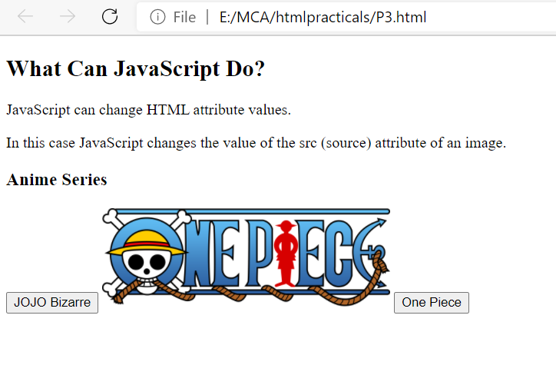

**5. Assignment on Jquery**

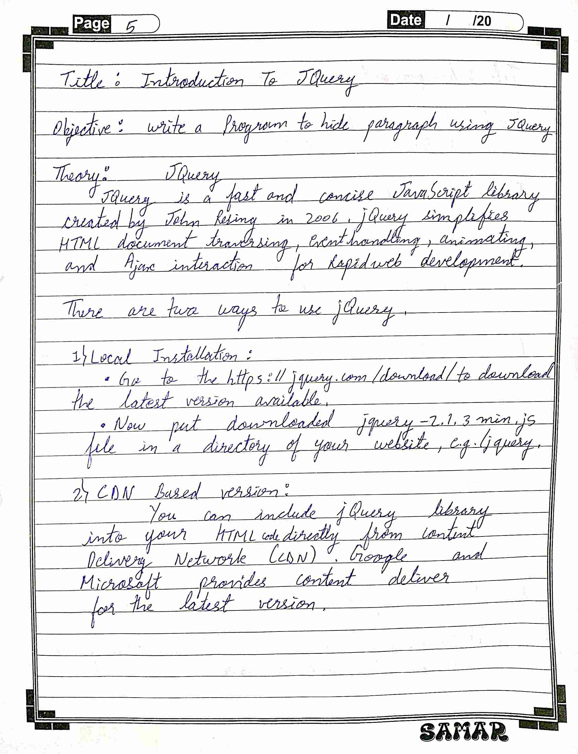

**Source Code:**

<!DOCTYPE html>

<html>

<head>

<script src="https://ajax.googleapis.com/ajax/libs/jquery/3.5.1/jquery.min.js"></script>

<script>

$(document).ready(function(){

$("button").click(function()

{

$("p").hide();

});

});

</script>

</head>

<body>

<h2>JOJO Bizarre adventure</h2>

<p>This is a paragraph.</p>

<p>This is another paragraph.</p>

<button>hide paragraphs</button>

</body>

</html>

**Output:**

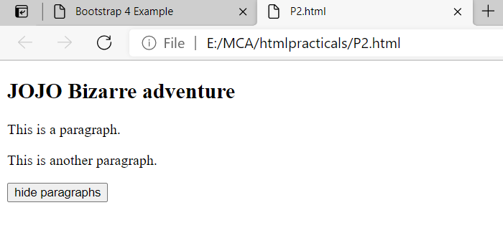



**6. Assignment on PHP basic**

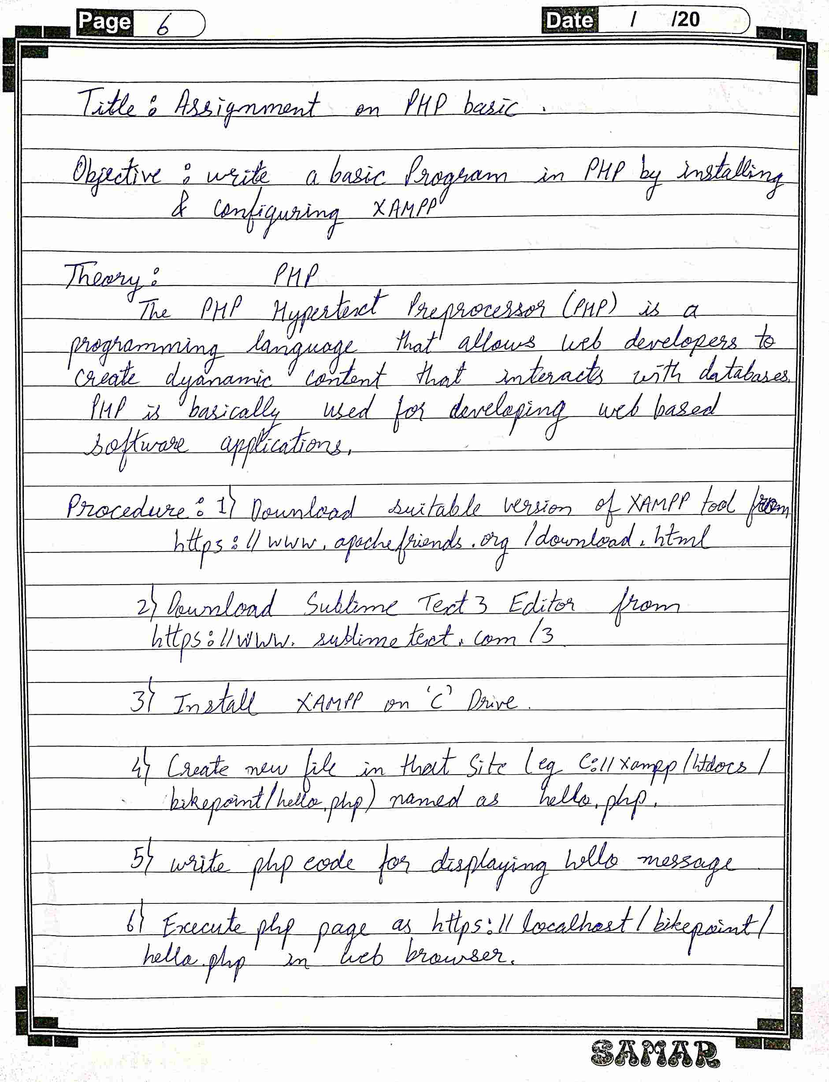

**Source Code :**

P4.php

<html>

<body>

<form action="welcome.php" method="post">

Name: <input type="text" name="name"><br>

E-mail: <input type="text" name="email"><br>

<input type="submit">

</form>

</body>

</html>

Welcome.php

<html>

<body>

Welcome <?php echo $_POST["name"]; ?><br>

Your email address is: <?php echo $_POST["email"]; ?>

</body>

</html>

**Output:**

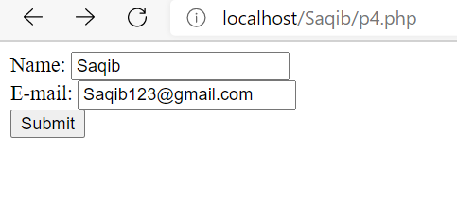

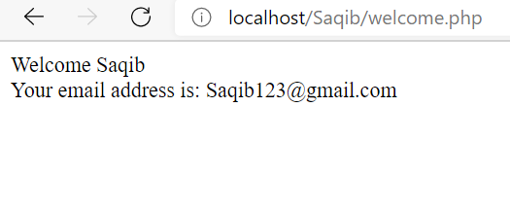

**7. Assignment on database operation in PHP**

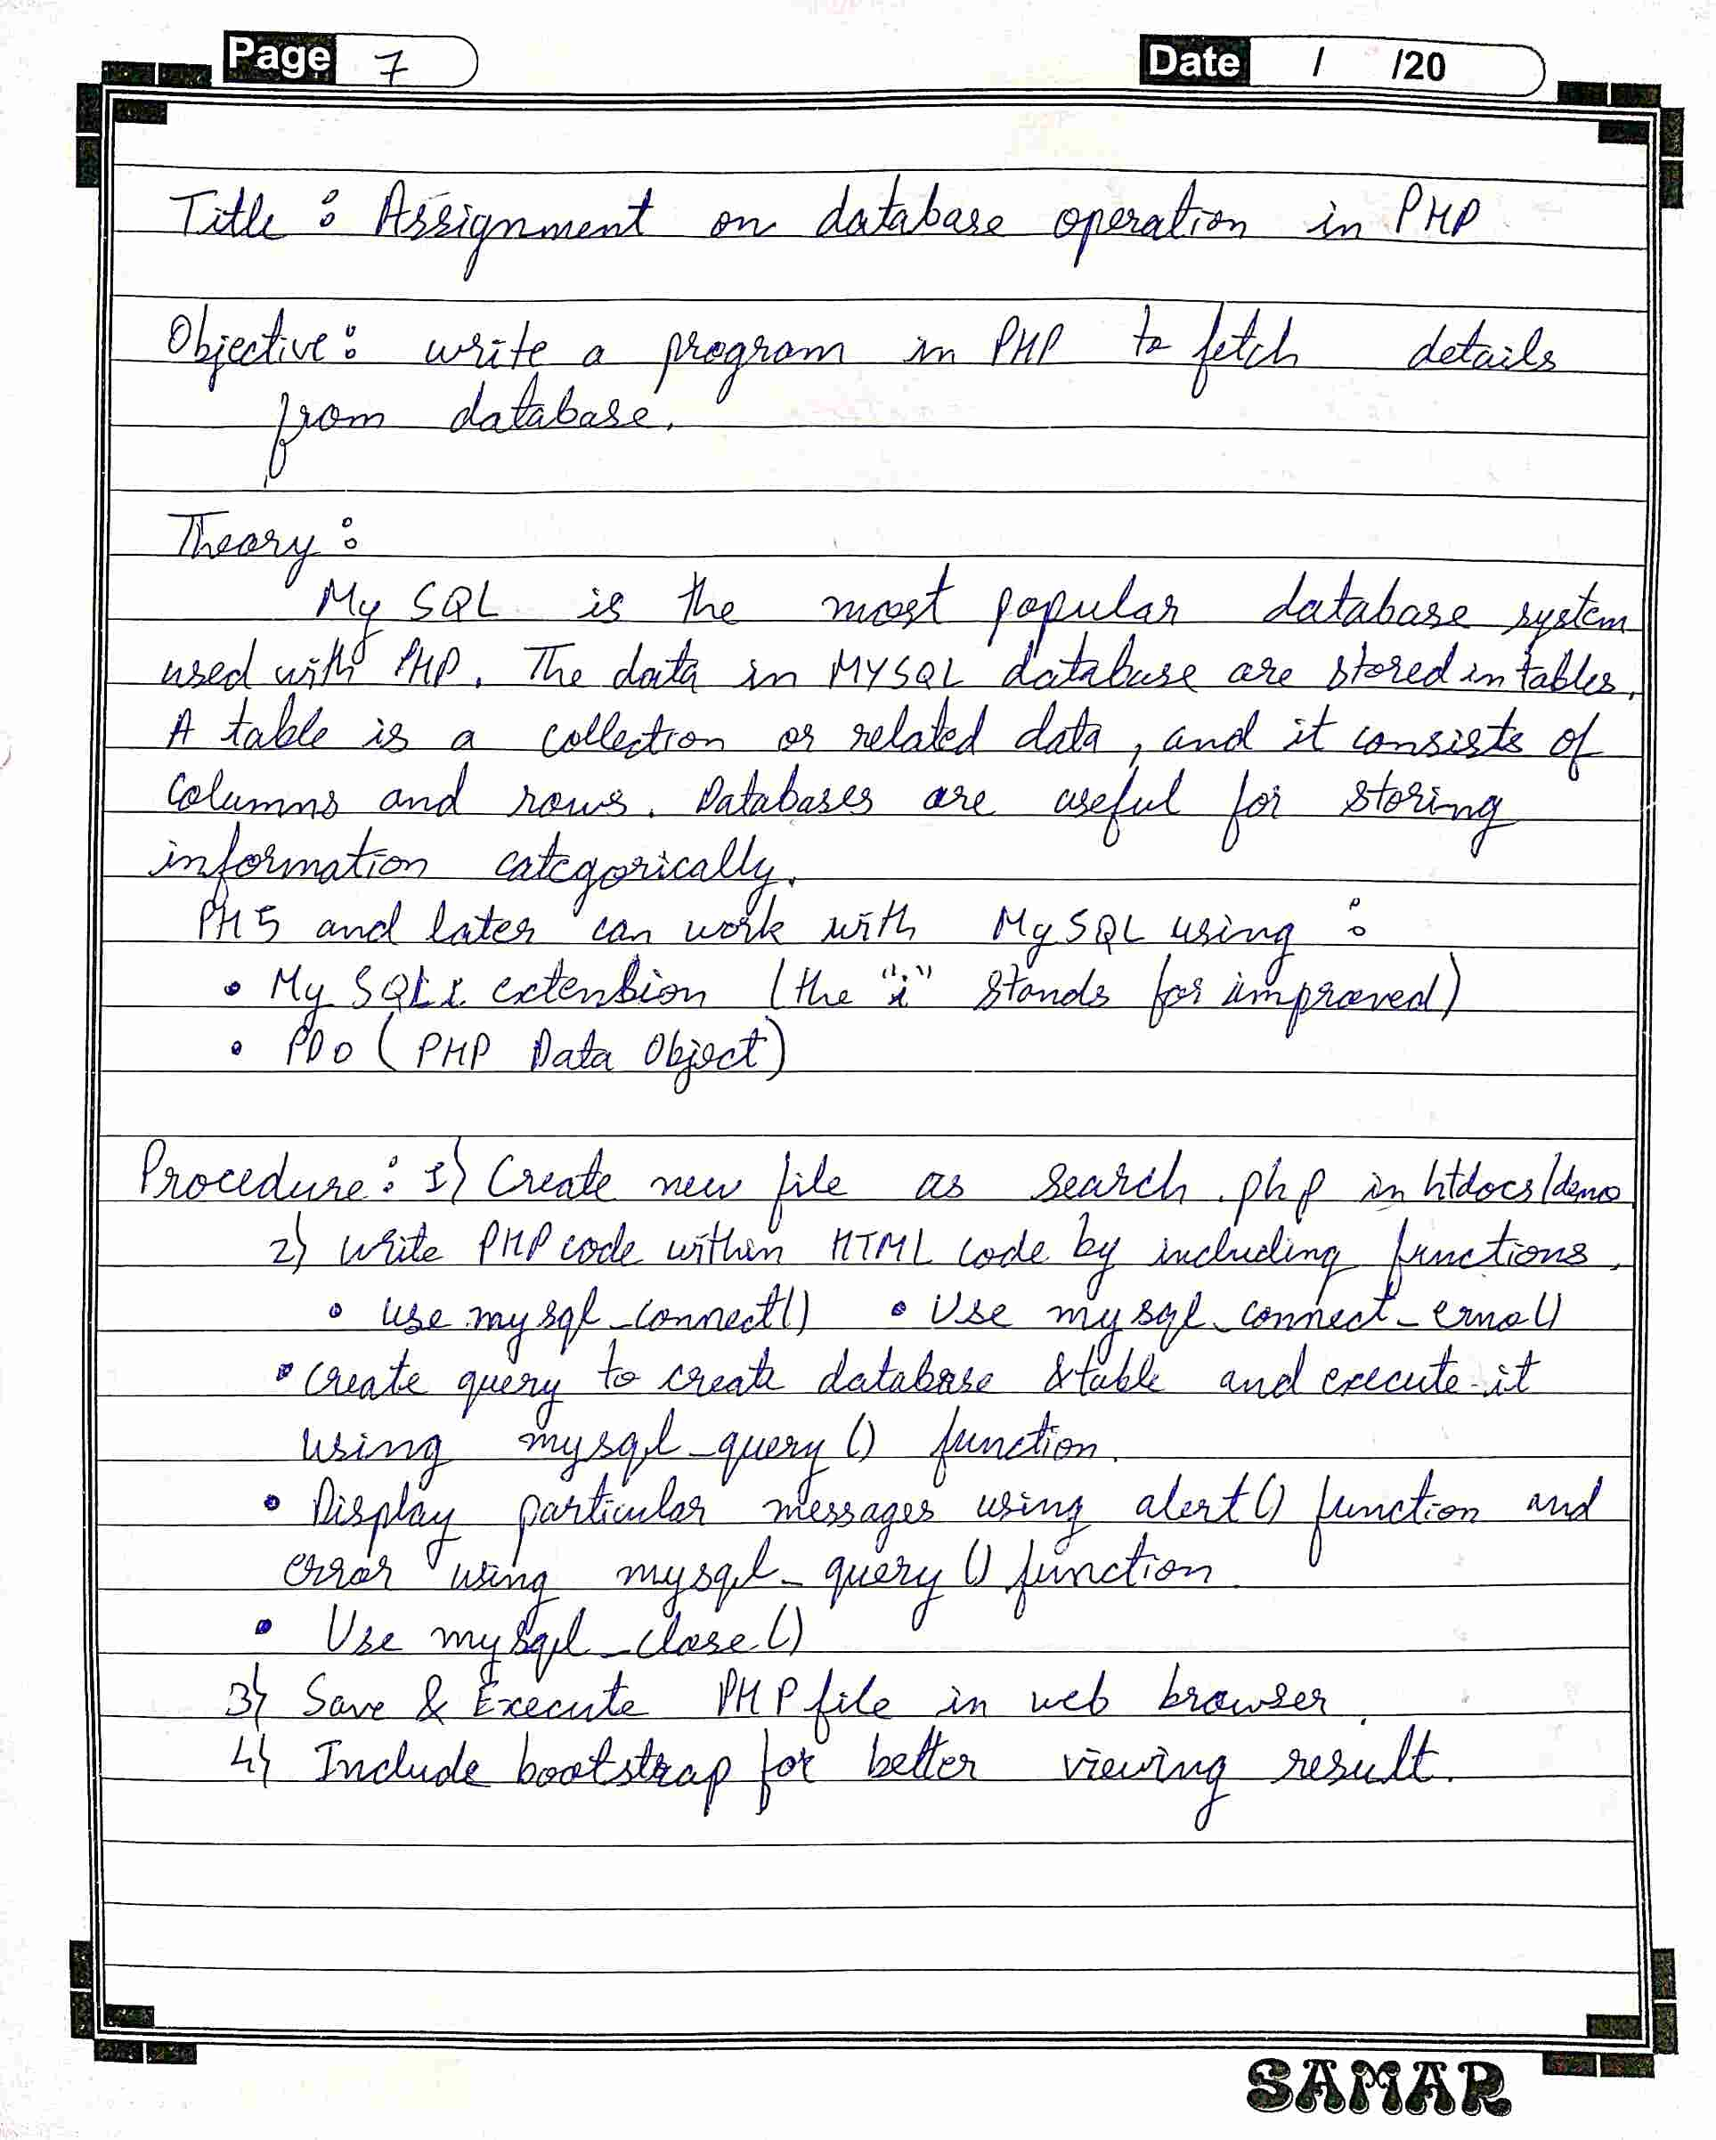

**Source Code:**

<html>

<head>

<!-- Required meta tags -->

<meta charset="utf-8">

<meta name="viewport" content="width=device-width, initial-scale=1, shrink-to-fit=no">

<!-- Bootstrap CSS -->

<link rel="stylesheet" href="https://stackpath.bootstrapcdn.com/bootstrap/4.4.1/css/bootstrap.min.css" integrity="sha384-Vkoo8x4CGsO3+Hhxv8T/Q5PaXtkKtu6ug5TOeNV6gBiFeWPGFN9MuhOf23Q9Ifjh" crossorigin="anonymous">

<link rel="preconnect" href="https://fonts.gstatic.com">

<link href="https://fonts.googleapis.com/css2?family=Josefin+Sans:wght@100;400&display=swap" rel="stylesheet">

<style>

*{

margin:0; padding: 0;

font-family: 'Josefin Sans', sans-serif;

}

</style>

</head>

<body bgcolor="blue">

<h2 align = "center">SEARCH RESULTS</h2>

<?php

$conn = mysqli_connect("localhost","root","root","p5") or die("Cannot connect");

?>

<form id="form" action="<?php $PHP_SELF ?>" method="post" class="text-center">

<input type="text" name="name" />

<input type ="submit" name="search" value="search" class="btnbtn-primary"/>

</form>

<?php

if(isset($_POST["search"]))

{

$name1 = $_POST["name"];

if($name1==NULL)

{

echo "Dont enter null values";

}

else

{

mysqli_select_db($conn,"p5") or die("Cannot select the database".mysqli_error($conn));

// $result1 = mysqli_query($conn,"selectid,name,emp_salary from emp5 ") or die("Cant select".mysqli_error($conn));

$result1 = mysqli_query($conn,"select id,name,emp_salary from emp5 where name= '".$name1."'") or die("Cant select".mysqli_error($conn));

}

echo "

<section>

<div class='container-fluid'>

<h1 class='text-center pt-5'>Data</h1>

<hr class='w-25 mx-auto pt-5'>

<div class='row mb-5 text-center'>

";

while($array = mysqli_fetch_row($result1))

{

echo " <div class='col-lg-3 col-md-3 col-sm-6 col-12'>

<div class='card'>

<img class='card-img-top' src='https://wallpapercave.com/wp/wp2276220.jpg' alt='Card image' >

<div class='card-body bg-success'>

<h4 class='card-title'>CGL</h4>";

echo "<p class='card-text'>".$array[0]." <br>".$array[1]."<br>".$array[2]."<br></p>";

echo " <a href='#' class='btnbtn-primary'>See Profile</a>

</div>

</div>

</div>

";

}

echo " </div>

</div>

</section>

";

}

?>

<a href="index.php" align = center>HOME</a>

</body>

</html>

**Output:**

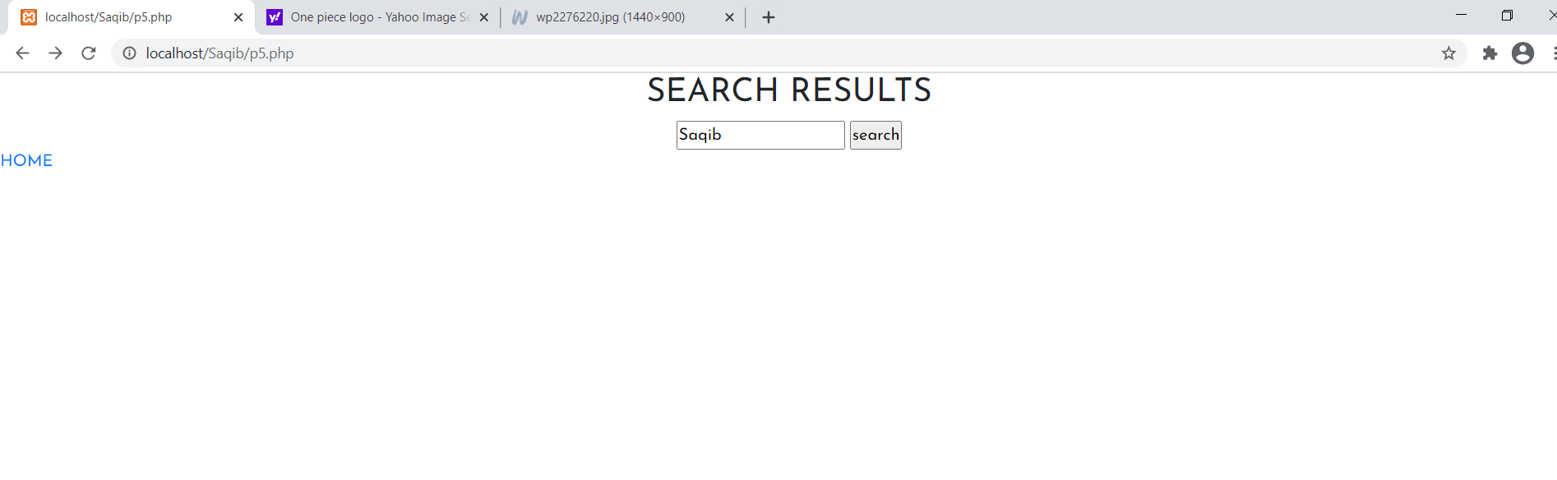

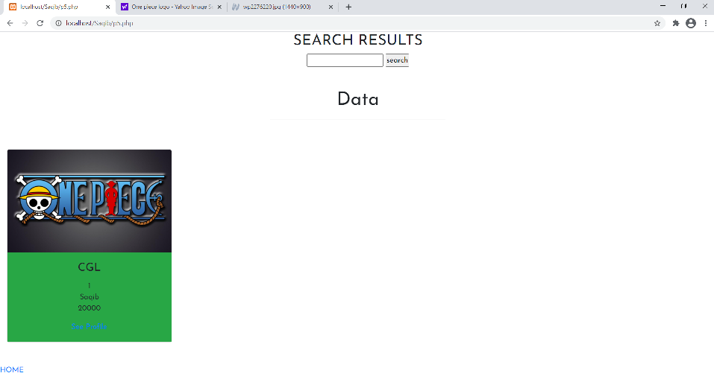

**8. Assignment on AJAX with PHP**

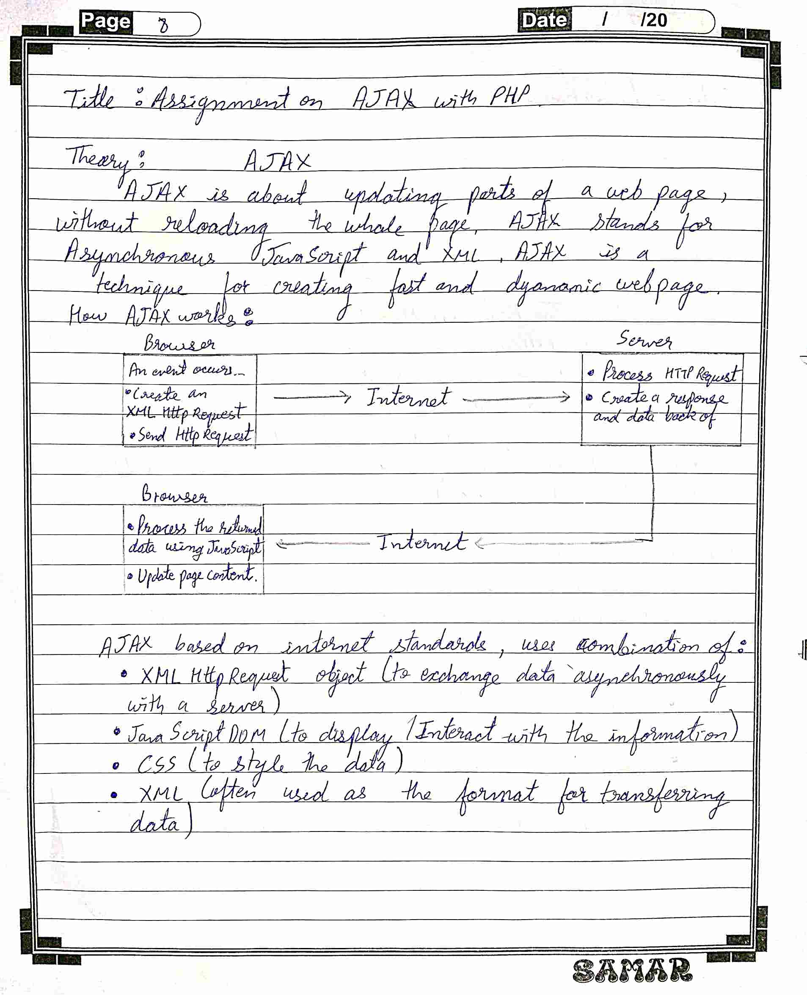

**Source Code:**

<!DOCTYPE html>

<html>

<head>

<script>

function showHint(str) {

if (str.length == 0) {

document.getElementById("txtHint").innerHTML = "";

return;

} else {

var xmlhttp = new XMLHttpRequest();

xmlhttp.onreadystatechange = function() {

if (this.readyState == 4 && this.status == 200) {

document.getElementById("txtHint").innerHTML = this.responseText;

}

}

xmlhttp.open("GET", "gethint.php?q="+str, true);

xmlhttp.send();

}

}

</script>

</head>

<body>

<p><b>Start typing a name in the input field below:</b></p>

<form action="">

<label for="fname">First name:</label>

<input type="text" id="fname" name="fname" onkeyup="showHint(this.value)">

</form>

<p>Suggestions: <span id="txtHint"></span></p>

</body>

</html>

gethint.php

<?php

// Array with names

$a[] = "Anna";

$a[] = "Brittany";

$a[] = "Cinderella";

$a[] = "Diana";

$a[] = "Eva";

$a[] = "Fiona";

$a[] = "Gunda";

$a[] = "Hege";

$a[] = "Inga";

$a[] = "Johanna";

$a[] = "Kitty";

$a[] = "Linda";

$a[] = "Nina";

$a[] = "Ophelia";

$a[] = "Petunia";

$a[] = "Amanda";

$a[] = "Raquel";

$a[] = "Cindy";

$a[] = "Doris";

$a[] = "Eve";

$a[] = "Evita";

$a[] = "Sunniva";

$a[] = "Tove";

$a[] = "Unni";

$a[] = "Violet";

$a[] = "Liza";

$a[] = "Elizabeth";

$a[] = "Ellen";

$a[] = "Wenche";

$a[] = "Vicky";

// get the q parameter from URL

$q = $_REQUEST["q"];

$hint = "";

// lookup all hints from array if $q is different from ""

if ($q !== "") {

$q = strtolower($q);

$len=strlen($q);

foreach($a as $name) {

if (stristr($q, substr($name, 0, $len))) {

if ($hint === "") {

$hint = $name;

} else {

$hint .= ", $name";

}

}

}

}

// Output "no suggestion" if no hint was found or output correct values

echo $hint === "" ? "no suggestion" : $hint;

?>

**Output:**

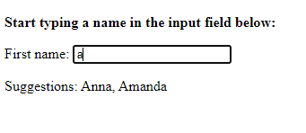

**9.Assignment on PHP Unit Testing**

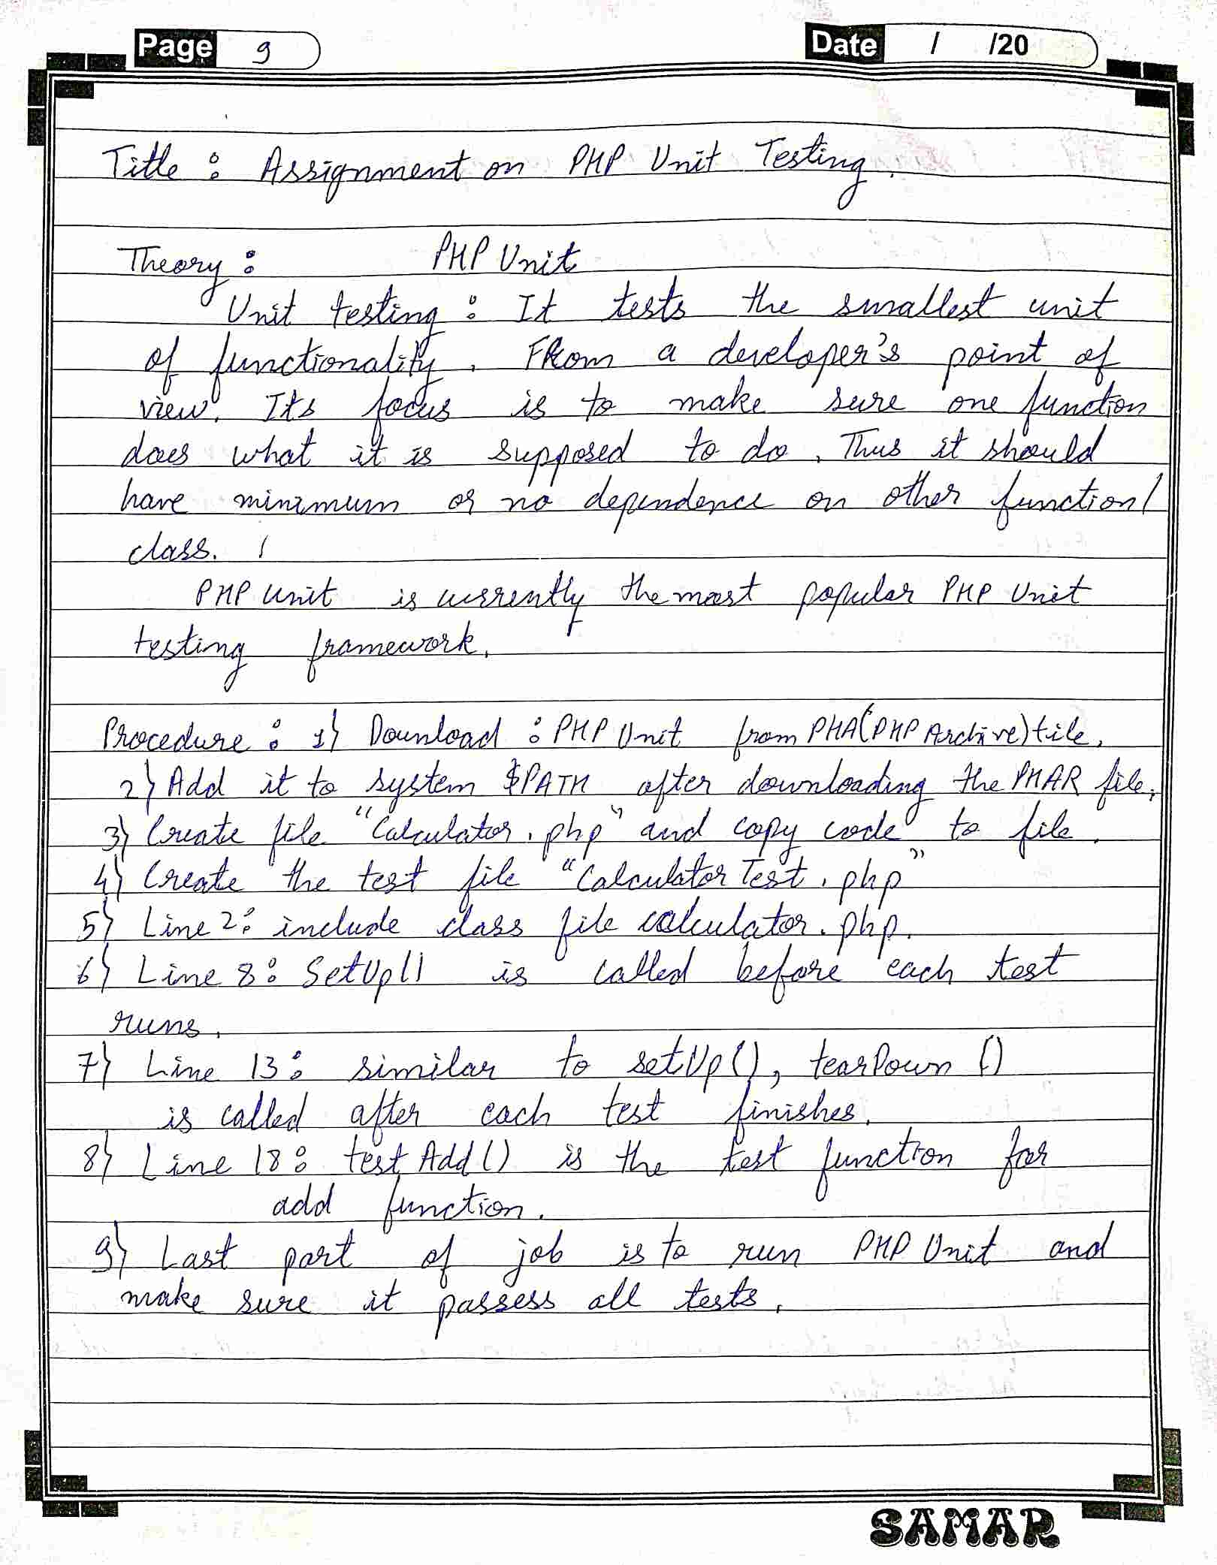

**Source Code:**

**P7.php**

<?php

class Calculator

{

public function mul($x,$y)

{

return $x * $y;

}

}

**CalculatorTests.php**

<?php

require 'p7.php';

class CalculatorTests extends PHPUnit_Framework_TestCase

{

private $calculator;

protected function setUp()

{

$this->calculator = new Calculator();

}

protected function tearDown()

{

$this->calculator = new Calculator();

}

protected function tearMul()

{

$result=$this->calculator->add(1,2);

$this->assertEquals(3,$result);

}

}

**Output:**

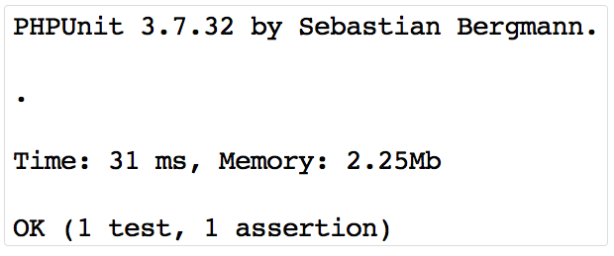

**10. Assignment on CMS:wordpress**

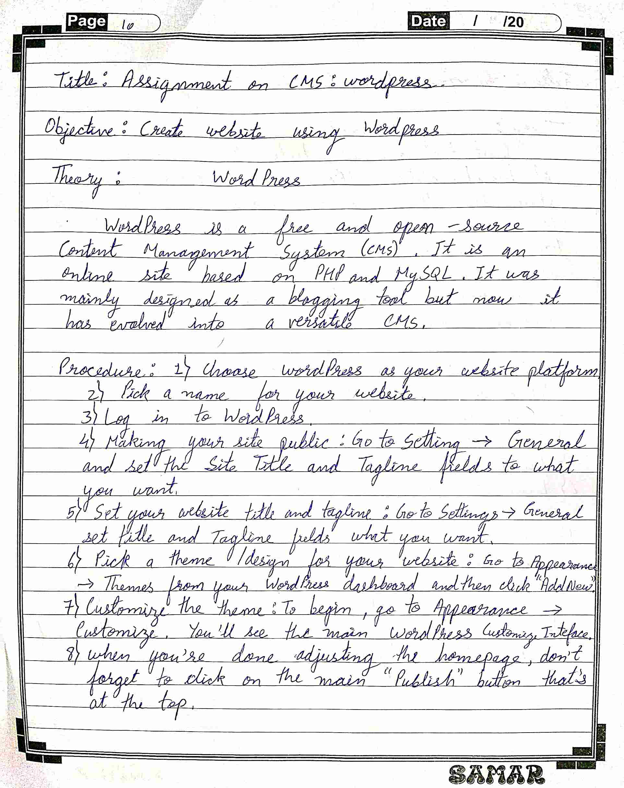

**Output :**

**11. Assignment on FTP client &Cpanel web hosting**

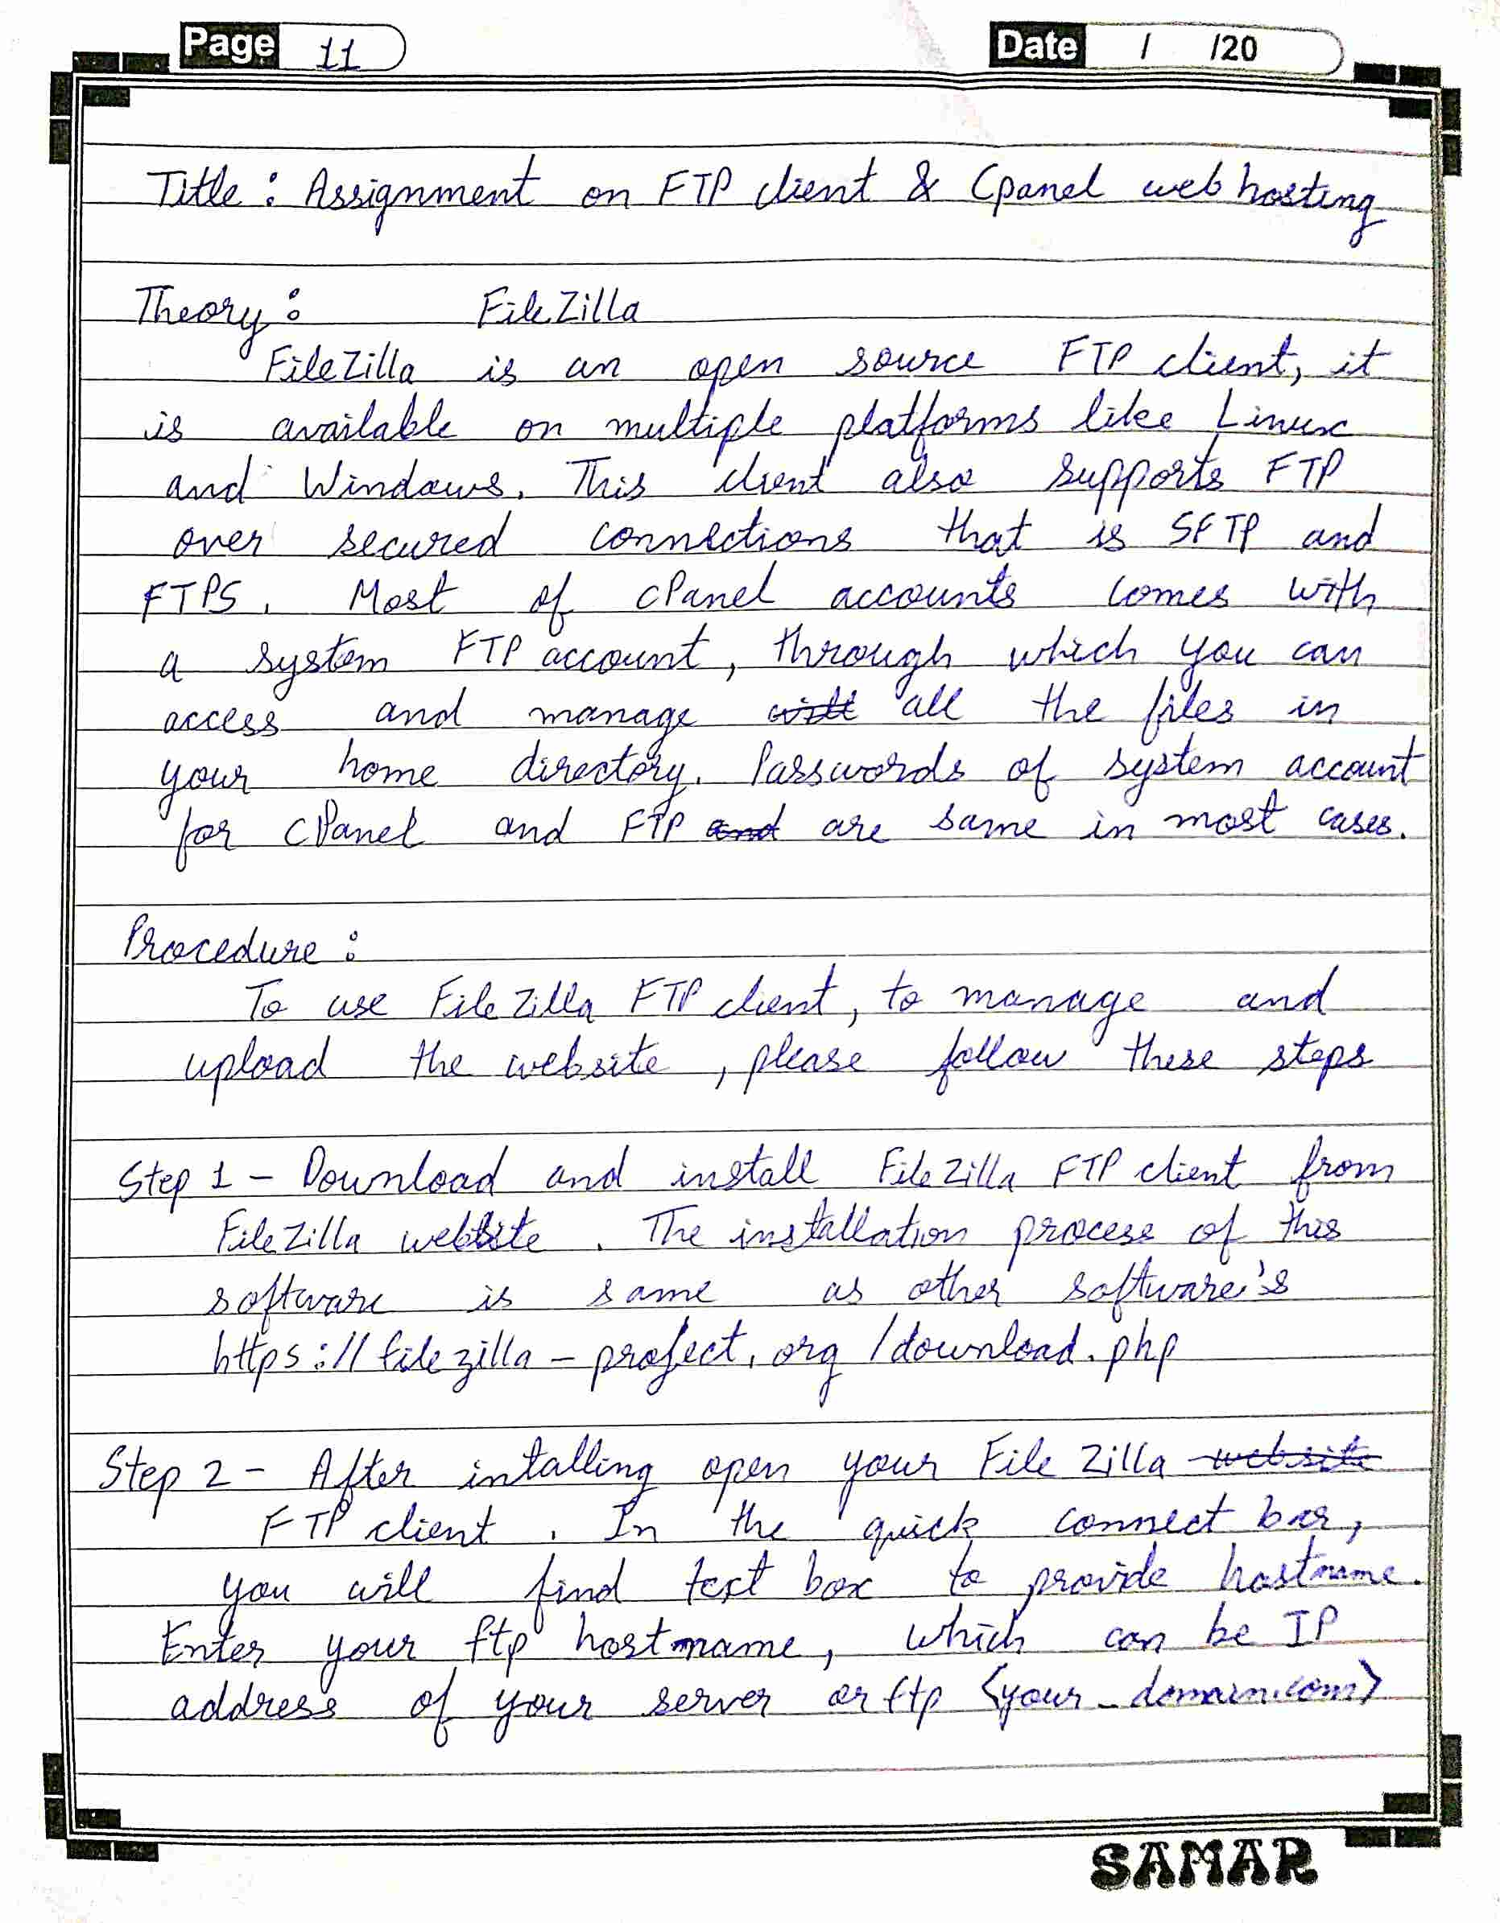

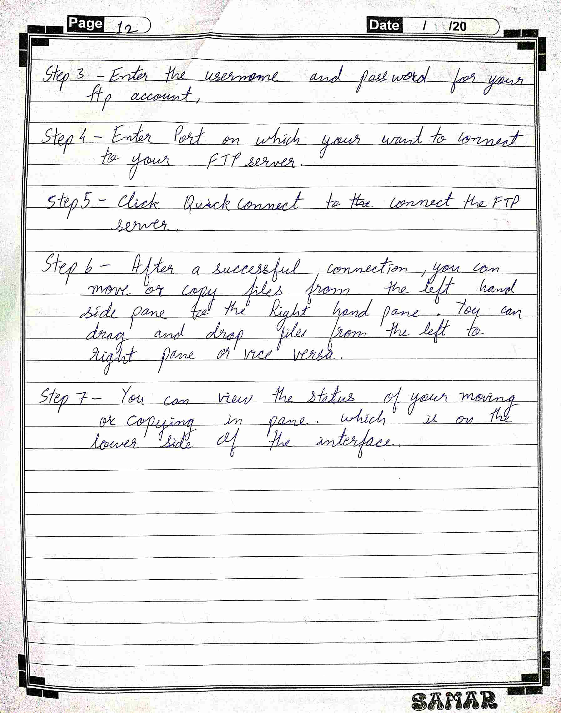

**Output :**

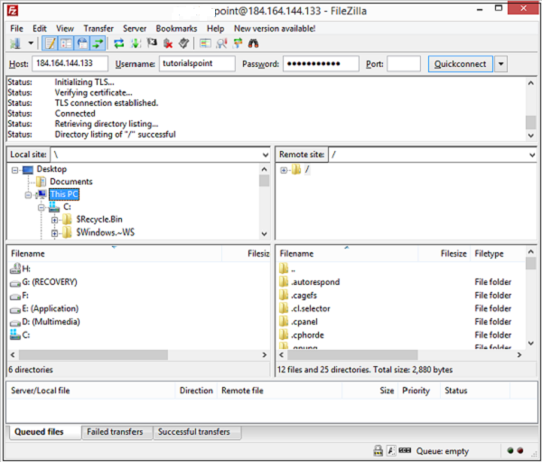

**12. Responsive Web Site development (Mini Project)**

**Title: (Urban Gear) Shoes Shopping.**

**Form Design**

**Login:**

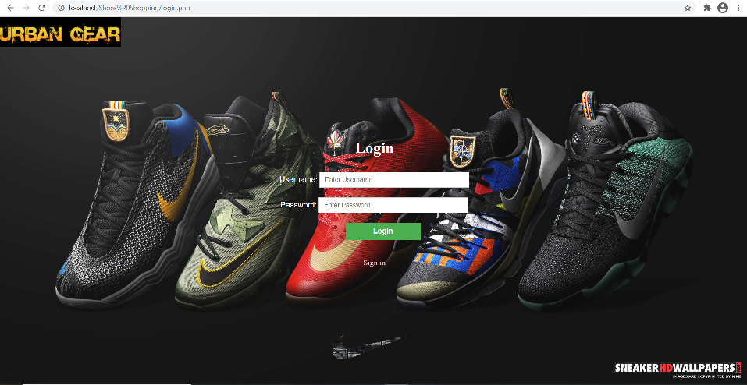

**Register:**

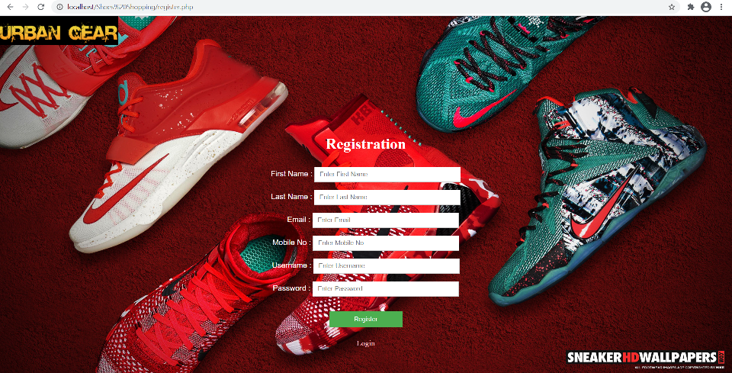

**Home:**

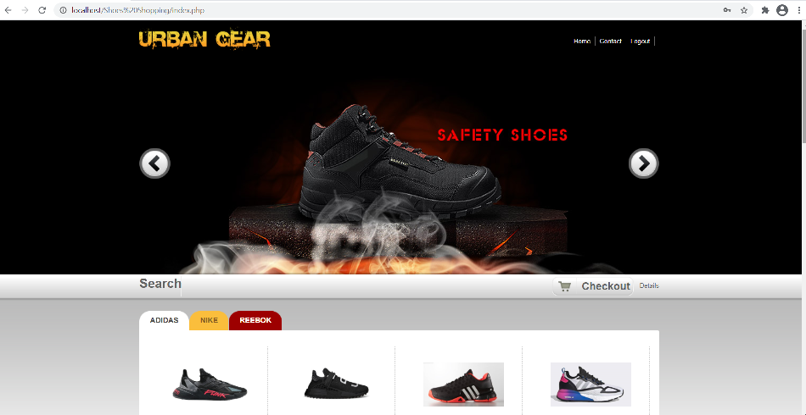

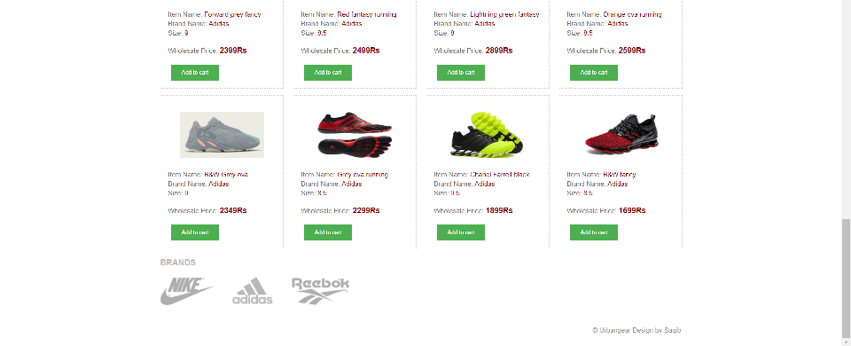

**Contact:**

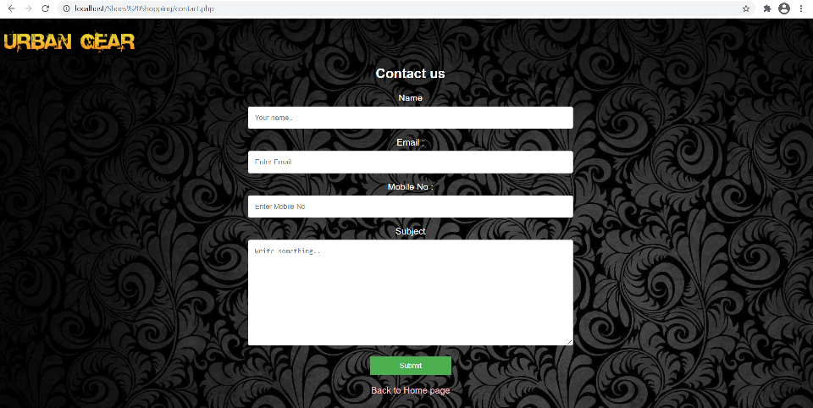

**Search:**

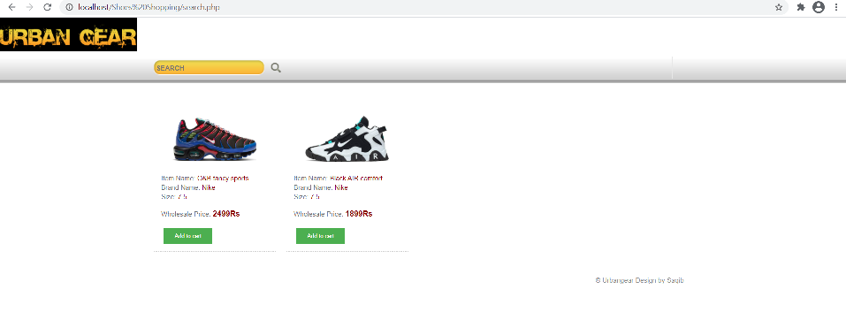

**Cart:**

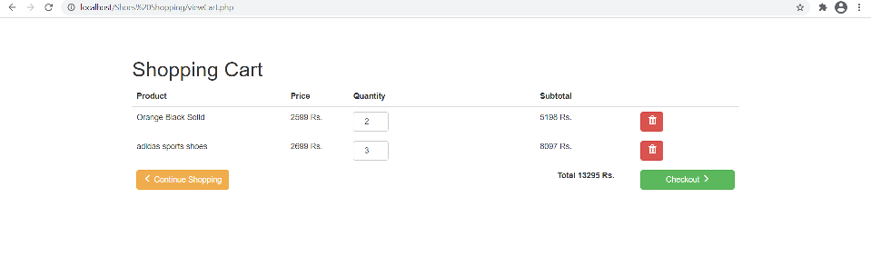

**Checkout:**

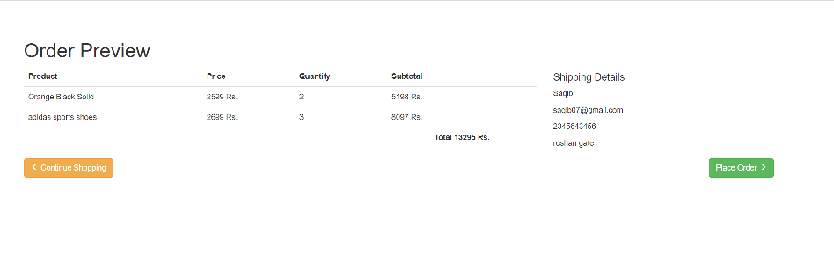**Admin Dashboard:**

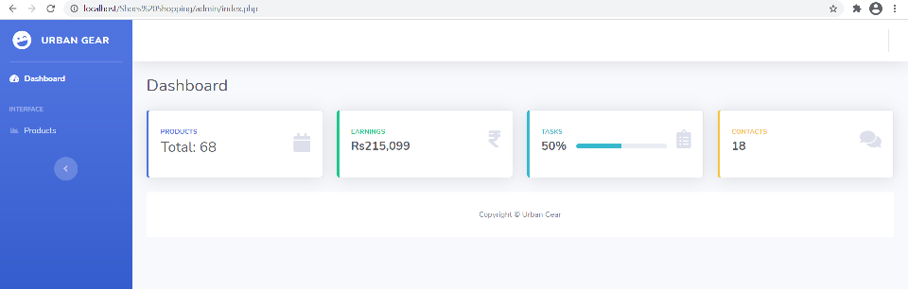

**Admin Products:**

